Proposed Rural development at Grace Farm,
Grouse Road, Colgate

Dear Neighbour,

We wanted to write to you in order to outline our vision for Grace Farm (currently referred to as ‘land adjacent to Blindman’s Wood’) and to help ensure that you are accurately informed about our plans and intentions.

Some of the greatest challenges facing rural England are the need to produce enough food to meet the growing demand for it and to efficiently deliver renewable energy alternatives to help reduce our dependence on fossil fuels. To achieve this and to keep the rural economy thriving, we need to embrace rural technologies that can help sustainably produce more food locally using fewer resources and support forestry and the management of our woodlands. A failure to meet these challenges is, perhaps, the greatest threat to the long-term future of our open countryside.

Our Vision is that, through the integration of two rural enterprises using innovative technologies, Grace Farm will pioneer a replicable agricultural model that will:

- Dramatically increase agricultural food production from the countryside without the need for GM or harmful pesticides.
- Efficiently produce high quality wood fuel with almost no environmental impact
- Facilitate and promote active woodland management and, thereby, help protect the long term health of our woodlands and forests
- Substantially enhance and protect the biodiversity of the land.
- Produce near zero waste.
- Increase employment and skill development in the rural economy.

Application for Planning

With this in mind, we have submitted a planning application to Horsham District Council in which we propose:

- To build an innovative and highly sustainable Aquaponic Solar Greenhouse (ASG) for the growing of fish, plants and mushrooms employing a process for which we recently received a Green Genius Award from the Government’s Technology Strategy Board (TSB).

- To re-establish two barns on the existing footprints of the original ones and install equipment on the existing area of hard standing, to facilitate the drying of high quality wood fuel.

- To deliver on a detailed Biodiversity Plan which includes:

- Planting a traditional orchard of apple, pear and stone fruit trees
- The creation of two wildlife ponds
- Planting of mixed, native hedgerows (to augment and improve existing stock fencing)
- Elimination of invasive weeds from the site (e.g. Ragwort and Knotweed)
- The creation of an extensive wildflower meadow

What will Grace Farm look like?

An artist’s impression of the re-established barns from the entrance on Grouse Road.

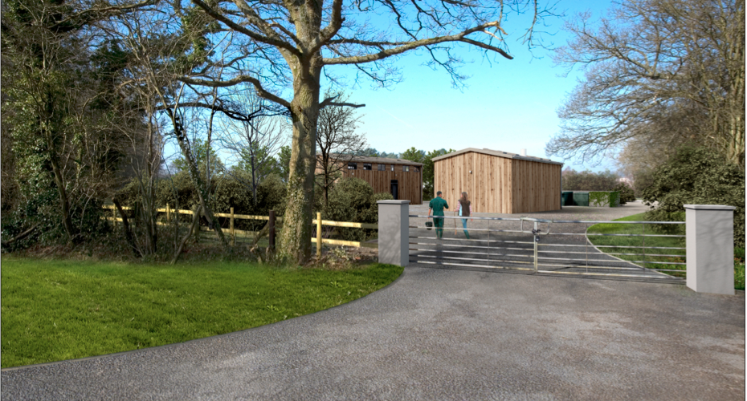

An artist’s impression of the Aquaponic Solar Greenhouse

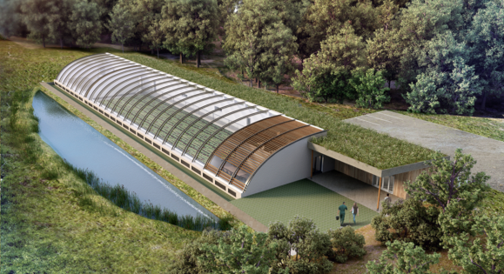

Impact on Local Amenity

Woodlands Lane: will not be used for any of our activities.

Large Vehicles: On average, there will be only 3 large vehicles attending Grace Farm and solely on weekdays. These will most likely comprise 2 tractors and 1 c.18t lorry.

Noise, smell or light pollution: No material impact.

Visual Impact: minimal

- the development will be screened and clustered to occupy less than an acre of the 16 acre site.
- wood will be dried on site using a low temperature (approx. 70°c) air drying process, thereby producing no appreciable visible vapour emissions.
- the vast majority of the site will be used for traditional agriculture, including low intensity grazing.

We recognise that any planning application, particularly one following a change of ownership of land within a local community, can cause some consternation. We very much hope that this letter to you will help avoid this and any misunderstanding that inevitably arises from a lack of access to all the facts. However, if anything remains unclear, or should you wish to raise any issues in confidence, or provide feedback on our plans; please feel free to contact any one of us using the contact details at the end of this letter. It is our intention to properly steward and care for the land, to be contributing members of the community and, above all, to be good neighbours. We would be delighted to meet you and introduce ourselves personally and to reassure you of the integrity and detailed consideration that has gone into every aspect of this application. A huge amount of work, to properly explore all aspects of our proposal and meet the planning guidance for such a development within the AONB, has been made available to Horsham District Council, and will be accessible to you via their planning portal.

It is our aim to be a benefit to the local community through a positive, low impact, rural development of this site. It will provide affordable, healthy, fresh food year-round and a local source of dry wood fuel; as well as local employment and skill development opportunities. We sincerely believe that our proposed plans directly, and positively, address key challenges that face our rural economy and will strengthen our ability to create local produce, with minimal impacts, and help to create a more resilient community as a result.

As a matter of interest, we are currently in the process of building an aquaponic greenhouse for Kate Humble (BBC Countryfile) at her farm in Monmouth and this has been received very positively by the local community, the local council and the Welsh Government. We hope that we can make an even more positive contribution to the Colgate community and, to this end, we would welcome your support.

With kind regards,

Charlie, Becky, Nick and Andrew

Charlie Price and Becky Bainbridge,
Nick Henderson and Andrew Parsons
c/o 2 Whitehouse Farm Cottage, Brantridge Lane,
Balcombe, RH17 6JP

Email: gracefarm@btinternet.com

